AI BLOGNEST API
PROJECT REPORT
AI-Enhanced Blog Management and Publishing API
Date | 28-09-2026
Team ID | SWTID-2026-8216
Project Name | AI BLOGNEST API

TEAM LEADER : Saidharshini K
EMAIL ID: sac2427bca5369@ssacollegachennai.com
TEAM MEMBER: Reshma Begum M
EMAIL ID: sac2427bac5275@ssacollegechennai.com
TEAM MEMBER: Shaheen Khatun R
EMAIL ID: sac2427bac5773@ssacollegechennai.com
TEAM MEMBER: Sabrin Saabira D
EMAIL ID: sac2427bca5392@ssacollegechennai.com

1. Introduction
BlogNest API is a modern backend application designed to provide a structured and reliable platform for creating, managing, publishing, and consuming blog content. The API acts as the communication layer between a frontend application and the backend services that store and process blog information. Instead of placing all application logic inside a user interface, BlogNest API exposes well-defined endpoints through which web or mobile applications can perform operations such as creating posts, viewing articles, updating content, managing users, and interacting with comments.
The project is designed with an AI-assisted approach. Artificial Intelligence can support content-related tasks such as generating initial drafts, suggesting titles, summarizing articles, improving readability, and recommending suitable tags. The API can therefore serve as the central backend for an intelligent blogging ecosystem while keeping the system modular and extensible.
The main objective of BlogNest API is to make blog management simpler, faster, secure, and scalable. By separating the backend API from the presentation layer, the same services can be used by websites, mobile applications, administrative dashboards, or other software clients.

2. What is BlogNest API?
BlogNest API is a REST-style application programming interface developed for a blog management system. An API, or Application Programming Interface, defines a set of rules and endpoints that allow different software components to communicate. In BlogNest, the client sends an HTTP request to an endpoint, the server validates and processes the request, and the API returns a structured response, commonly in JSON format.

Core API responsibilities
- User management: registration, authentication, profile information, and authorization.
- Blog management: creating, reading, updating, deleting, publishing, and organizing posts.
- Content interaction: comments, likes or reactions, tags, categories, and search.
- AI services: optional AI-powered content generation, summarization, title suggestions, and metadata assistance.
- Data management: storing and retrieving users, posts, comments, and related information from a database.
- Client communication: providing consistent HTTP endpoints for web, mobile, or other frontend clients.
A typical request may use an endpoint such as POST /api/posts to create a blog post or GET /api/posts to retrieve available posts. Authentication mechanisms can ensure that only authorized users can modify protected resources.

3. Why AI is Used
AI is used in BlogNest to reduce repetitive content-related work and improve the overall user experience. Traditional blogging systems generally require users to manually write, edit, summarize, categorize, and optimize every article. AI can assist with these activities while leaving the final decision and publishing control with the user.

Possible AI capabilities
- AI-assisted content generation: creates a first draft from a topic or set of instructions.
- Title generation: suggests multiple relevant and engaging titles for an article.
- Summarization: converts a long article into a short summary for previews or feeds.
- Grammar and readability assistance: identifies unclear sentences and suggests improvements.
- Tag and category suggestions: analyzes article content and recommends relevant metadata.
- Semantic search: helps users find articles based on meaning rather than only exact keywords.
- Personalized recommendations: can suggest articles based on topics or interaction history.
AI should be integrated as an assisting service rather than as an uncontrolled publishing mechanism. Generated content should be reviewed by the author, and the application should provide appropriate validation, privacy controls, and safeguards against misleading or inappropriate output.

4. Main Features

4.1 User Authentication and Authorization
Users can create accounts and sign in securely. Authentication identifies the user, while authorization determines what actions that user is permitted to perform. For example, an author may edit their own post while an administrator may manage a wider set of resources.

4.2 Blog Post Management
The API supports the complete blog-post lifecycle: creation, retrieval, editing, deletion, draft management, and publication. Posts can contain a title, body, author information, timestamps, categories, tags, and publication status.

4.3 Search and Filtering
Users can search posts and filter them using keywords, categories, tags, authors, or other metadata. Pagination can be implemented so that large numbers of posts do not need to be returned in a single response.

4.4 Comments and Engagement
The platform can provide comments and reactions to encourage interaction between readers and authors. Authentication and moderation rules can be applied to reduce misuse.

4.5 AI Content Assistance
AI endpoints can accept a topic or existing text and return suggestions such as a draft, title, summary, tags, or improvements. These services can be kept separate from core blog operations to make the architecture easier to maintain.

4.6 API Documentation and Error Handling
Clear endpoint documentation helps frontend developers understand request formats, authentication requirements, response structures, and error codes. Consistent errors make the API easier to debug and integrate.

5. Working Process
The BlogNest API follows a request-response workflow. The frontend or another client sends an HTTP request to the appropriate endpoint. The backend validates the request, applies business logic, communicates with the database or AI service when necessary, and returns a structured response.
- User interaction: The user enters information through a web or mobile interface.
- API request: The client sends an HTTP request containing the required data and authentication information.
- Authentication and validation: The server verifies identity and checks whether the submitted data is valid.
- Business logic: The application performs the requested operation, such as creating a post or retrieving articles.
- Database operation: The backend reads or writes the relevant records in the database.
- AI processing: If an AI feature is requested, the backend sends an appropriate prompt or structured input to the AI service and processes its response.
- API response: The server returns a JSON response containing the result, status information, or a meaningful error message.
- Frontend display: The client uses the response to update the screen and show the result to the user.

Example: Creating a Blog Post
- The author enters the title and article content.
- The frontend sends a POST request to the blog-post endpoint.
- The API checks the user's authentication token and validates the input.
- The backend stores the post in the database.
- If requested, an AI service generates a summary or suggested tags.
- The API returns the created post and its metadata as a JSON response.

6. Technologies
The following technology stack can be used to implement BlogNest API. The exact framework or database may be selected according to project requirements, but the architecture remains based on standard web API principles.
Layer | Technology | Purpose
Frontend | HTML, CSS, JavaScript and/or a modern framework such as React/Next.js | Provides the user interface that communicates with the API.
Backend | Node.js with Express.js or another REST API framework | Handles routing, validation, authentication, business logic, and API responses.
Database | PostgreSQL / MySQL / MongoDB | Stores users, posts, comments, categories, tags, and other application data.
AI Service | Generative AI / NLP API | Supports drafting, summarization, title suggestions, tagging, and other intelligent features.
API Format | REST + JSON | Provides a standard and lightweight communication format between clients and the server.
Authentication | JWT or secure session-based authentication | Protects user accounts and restricted API operations.
Development Tools | VS Code, Git, GitHub, Postman | Supports coding, version control, API testing, and collaboration.

7. Advantages
- Centralized backend: Core blog operations are managed through a common API.
- Platform independent: The same API can serve web applications, mobile applications, and other clients.
- Faster content creation: AI assistance can reduce repetitive writing and editing tasks.
- Scalable architecture: Modular API services can be expanded as the number of users and posts grows.
- Improved maintainability: Separating frontend and backend makes the application easier to update.
- Structured data handling: A database provides organized storage and efficient retrieval of content.
- Better developer experience: Consistent endpoints, JSON responses, and documentation simplify integration.
- Extensible design: New services such as notifications, analytics, recommendation systems, or moderation can be added later.

8. Future Enhancements
BlogNest API can be extended into a complete intelligent publishing platform. Future versions can focus on personalization, performance, security, and richer creator tools.
- AI-powered personalized article recommendations based on user-selected interests and reading history.
- Advanced semantic search using embeddings or vector databases.
- Multilingual content assistance for creating and translating articles into multiple languages.
- AI-powered moderation to flag potentially harmful, spam, or policy-violating content for review.
- Analytics dashboard showing views, engagement, popular posts, and author-level statistics.
- Scheduled publishing and content calendars for authors.
- Media management for images, videos, and documents with optimized storage.
- Notifications through email or push services for comments, followers, and published posts.
- Role-based administration with detailed permissions for authors, editors, and administrators.
- Caching, rate limiting, logging, monitoring, and cloud deployment for production-scale usage.
- Automated API testing and continuous integration/continuous deployment (CI/CD) pipelines.

9. Conclusion
BlogNest API provides a structured foundation for a modern blogging platform by separating the application's user interface from its backend services. It can manage users, blog posts, comments, search, and other content operations through clearly defined API endpoints. The use of AI adds an intelligent assistance layer that can support authors with drafting, summarization, titles, tags, and other content-related activities.
The project demonstrates important concepts in modern software development, including REST APIs, database management, authentication, client-server communication, modular architecture, and AI integration. With additional security, testing, analytics, scalability, and deployment features, BlogNest API can be developed further into a complete and practical content management platform.

SCREENSHOTS:

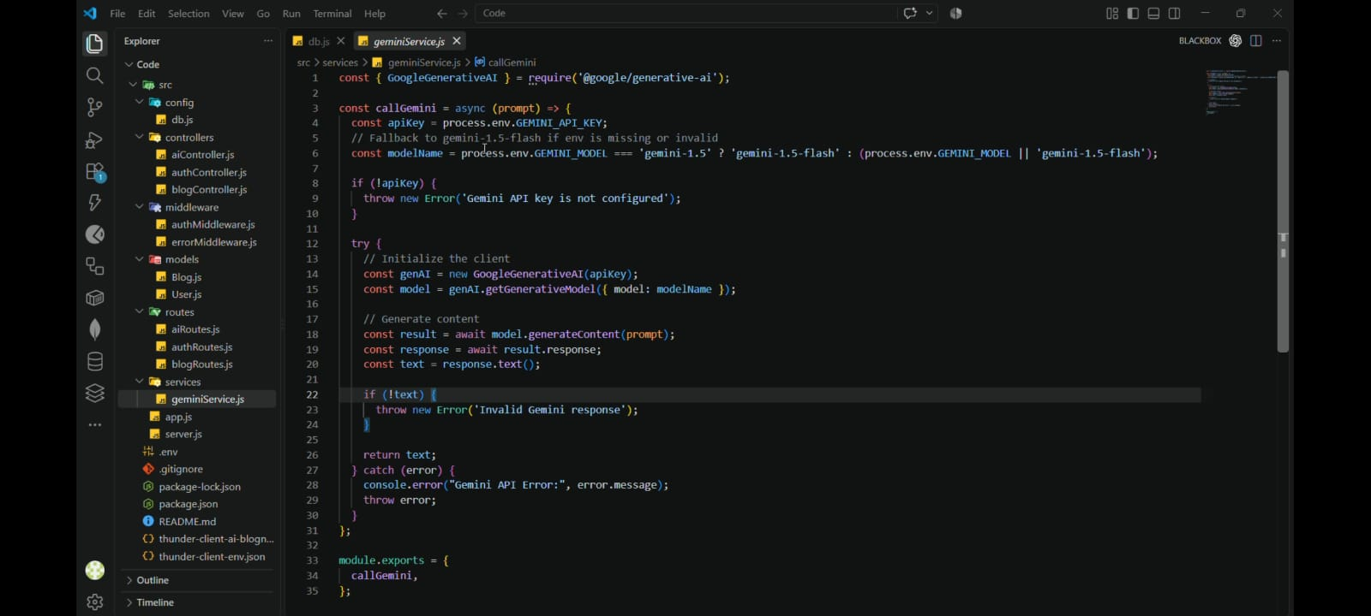

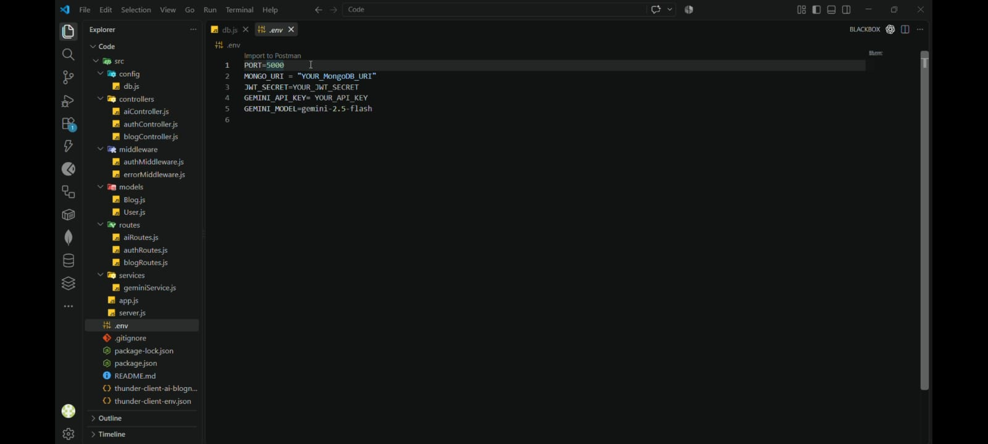

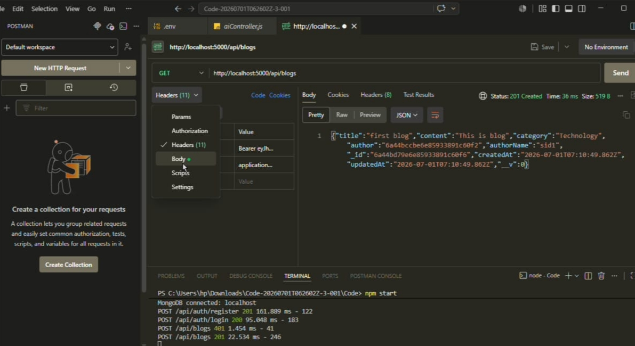

DEMO VIDEO LINK:
https://drive.google.com/file/d/1K45MmJzESpgrpV8VIiAd6srSI9lcOufb/view?usp=drive_link
API VIDEO LINK:
https://drive.google.com/file/d/1K45MmJzESpgrpV8VIiAd6srSI9lcOufb/view?usp=drive_link
GITHUB LINK:
https://github.com/sac2427bca5369-prog/AI-Blognest.git

